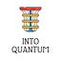

Into Quantum
SubscribeSign in
Read in the Substack app
Open app

A Lesson On Single-Qubit Quantum Gates (Part 1)

Learn about the Identity gate, Pauli gates and the Hadamard gate in this lesson.



Dr. Ashish Bamania
May 13, 2025
5
3


Image generated with Google ImageFX
We have previously discussed the mathematics behind Quantum gates in depth, which is an important lesson to take before this one.



A Deep Dive Into The Mathematics Of Quantum Gates
Dr. Ashish Bamania
·
13 Apr

Read full story

This week’s lesson is all about single-qubit quantum gates.
Let’s begin!
Into Quantum is a reader-supported publication. To receive new posts and support my work, consider becoming a free or paid subscriber.
Top of Form
Subscribe
Bottom of Form

What Are Single-Qubit Quantum Gates?
Single-qubit quantum gates act and operate on individual qubits to manipulate their quantum state.
Each quantum gate represents the rotation of a point representing a qubit on the Bloch sphere.
Since there are infinitely many possible rotation axes and each axis can have infinitely many rotation angles, the space of all possible operations on a qubit is uncountably infinite.
Therefore, there are uncountably infinite single-qubit gates.
Some of these gates are more commonly used and hence named. We will discuss these gates in more detail next.

1. Identity Gate
This gate, when applied to a qubit, preserves its state or leaves it unchanged.

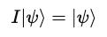

where the Identity gate is represented by I and the following matrix:

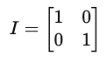

It is represented by the following symbol in a quantum circuit diagram:

For example, I applied to |0> returns |0>.

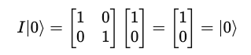

And, I applied to |1> returns |1>.

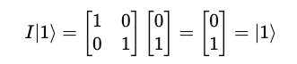

2. Pauli Gates
There are three Pauli gates are follows:
- X-gate: which causes a bit flip (like the classical NOT gate) for a qubit state

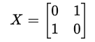

It is represented by the following symbols in a quantum circuit diagram:

or,

- Y-gate: which causes a combination of a bit flip and a phase flip for a qubit state

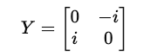

It is represented by the following symbol in a quantum circuit diagram:

- Z-gate: which causes a phase flip for a qubit in the state |1> but leaves |0⟩ unchanged.

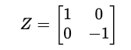

It is represented by the following symbol in a quantum circuit diagram:

We have discussed these gates in a lot of depth previously. In case you missed it, this lesson can be found here.

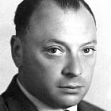

A Lesson On Pauli Matrices As Quantum Gates
Dr. Ashish Bamania
·
25 Apr

Read full story

3. Hadamard Gate
This gate is used to create a quantum superposition state.
It is represented by the following matrix:

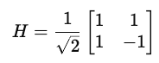

It is represented by the following symbol in a quantum circuit diagram:

When H acts on |0>, it creates the following superposition state:

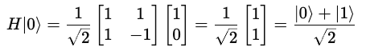

This looks as follows on the Bloch sphere:

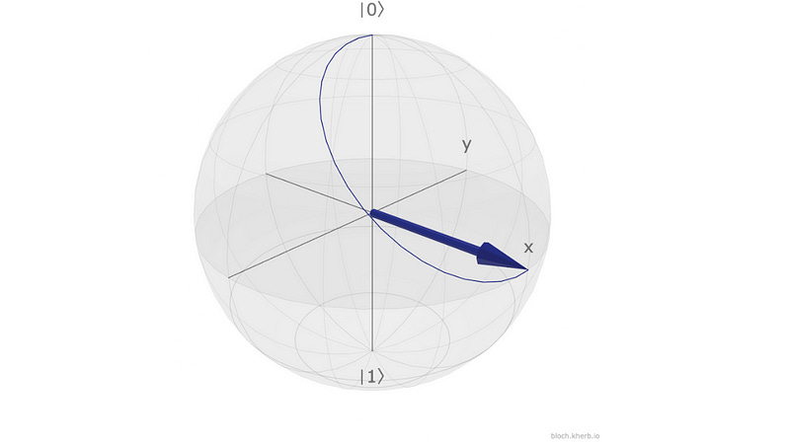
Hadamard gate applied to |0> (Image created using Bloch sphere simulator)
And when H acts on |1>, it creates the following superposition state:

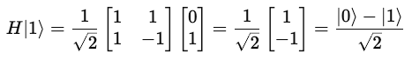

This looks as follows on the Bloch sphere:

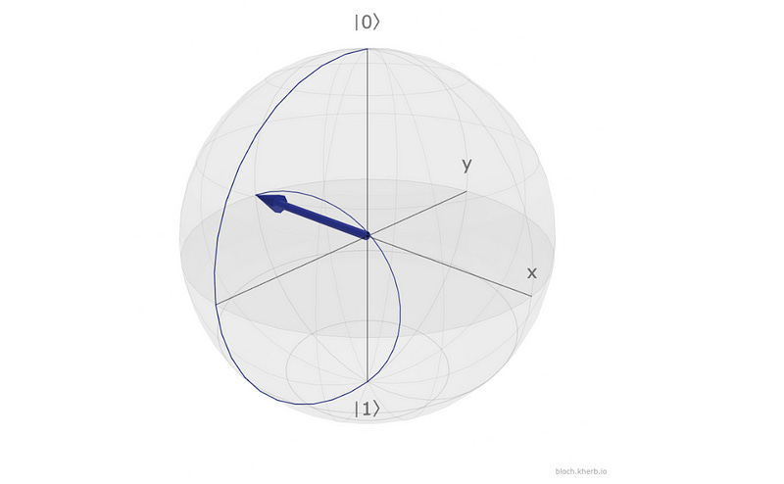
Hadamard gate applied to |1> which is prepared by applying Pauli-X gate to |0> (Image created using Bloch sphere simulator)
The resulting states are equal superposition states with opposite relative phases or a relative phase difference of π.
We have previously discussed applying the Hadamard gate to build a quantum circuit on a real quantum computer.
In case you missed this lesson, it can be found here.



Your First Quantum Program: Build A Truly Random Number Generator With Qiskit
Dr. Ashish Bamania
·
14 Mar

Read full story

This lesson on single-qubit gates is divided into multiple parts to keep it short and easy to grasp.
Thanks for being a curious reader of “Into Quantum”, a publication that aims to teach Quantum Computing from the very ground up.
See you soon in the next lesson!

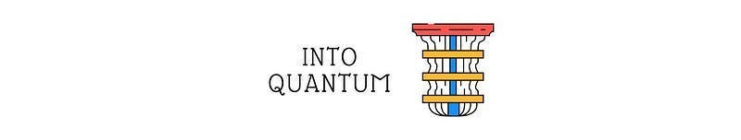

Into Quantum is a reader-supported publication. To receive new posts and support my work, consider becoming a free or paid subscriber.
Top of Form
Subscrib
Bottom of Form

